**Designing The StudentOptionsFrame**

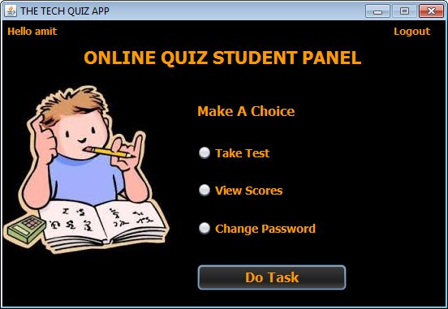

**STEPS TO BE DONE IN** **StudentOptionsFrame**

In the **StudentOptionsFrame** we need to do following steps:

1. Display **username** on the top left

2. Allow the user to **logout**

3. Provide the following options:

**Take Test**

**View Score**

**Change Password**

**Displaying The Username**

Same as **AdminOptionsFrame**

**Allowing The User To Logout**

Same as **AdminOptionsFrame**

**Handling The Options**

The next task is to allow the Student to select an options amongst **Take Test,View Score** and **Change Password**

To do this we need to handle the "**Do Task**" Button in the following way:

**a. We will first validate whether any option has been selected or not.**

**b. If not , then we will generate an error message and return.**

**c. Otherwise:**

**i) If Take Test option is selected it should open the ChoosePaperFrame**

**ii)If View Scores option is selected , then it should first verify whether the student has appeared for any exam or not . If he has not appeared for any exam then a message should be displayed mentioning "You haven't appeared for any exam yet!" , otherwise ViewStudentScoresFrame should be opened**

**iii) If Change Password option is selected it should open the ChangePasswordFrame**

**iv) Finally the current frame should be disposed**

**HOW TO VERIFY WHETHER STUDENT HAS APPEARED FOR ANY EXAM OR NOT:**

Before we can open the **ViewStudentScoreFrame** , we must verify whether the student has appeared for any exam or not.

To do this we will create a method called **getAllExamId( )** in the **PerformanceDAO**.which will accept the student id/name as argument and return the list of exam id's in which he has appeared.

The prototype of the method is:

***public static ArrayList<String> getAllExamId(String studentId)throws SQLException***

Following is it's code:

***public static ArrayList<String> getAllExamId(String studentId)throws SQLException***

***{***

***String qry="select examid from performance where userid=?";***

***ArrayList<String> examIdList=new ArrayList<>();***

***Connection conn=DBConnection.getConnection();***

***PreparedStatement ps=conn.prepareStatement(qry);***

***ps.setString(1, studentId);***

***ResultSet rs=ps.executeQuery();***

***while(rs.next()){***

***String id=rs.getString(1);***

***examIdList.add(id);***

***}***

***return examIdList;***

***}***

**WRITING THE CODE FOR BUTTON Button.png IN StudentOptionsFrame**

***private boolean validateInputs(){***

***if(jrTakeTest.isSelected()==false && jrViewScores.isSelected()==false && jrChangePassword.isSelected()==false)***

***return false;***

***return true;***

***}***

***private void btnTaskActionPerformed(java.awt.event.ActionEvent evt) {***

***if(validateInputs()==false){***

***JOptionPane.showMessageDialog(null, "Please Choose An Option","Error!",JOptionPane.ERROR_MESSAGE);***

***return;***

***}***

***if(jrTakeTest.isSelected())***

***{***

***ChoosePaperFrame paperFrame=new ChoosePaperFrame();***

***paperFrame.setVisible(true);***

***}***

***else if(jrViewScores.isSelected())***

***{***

***try***

***{***

***ArrayList<String> examIdList=PerformanceDAO.getAllExamId(UserProfile.getUSername());***

***if(examIdList.size()==0){***

***JOptionPane.showMessageDialog(null, "You haven't appeared for any exam yet!","No Records!!",JOptionPane.INFORMATION_MESSAGE);***

***return;***

***}***

***ViewStudentScoreFrame scoreFrame=new ViewStudentScoreFrame(examIdList);***

***scoreFrame.setVisible(true);***

***}***

***catch(SQLException ex){***

***JOptionPane.showMessageDialog(null, "Error while connecting to DB!","Exception!",JOptionPane.ERROR_MESSAGE);***

***ex.printStackTrace();***

***}***

***}***

***else if(jrChangePassword.isSelected())***

***{***

***ChangePasswordFrame passwordFrame=new ChangePasswordFrame();***

***passwordFrame.setVisible(true);***

***}***

***this.dispose();***

***}***